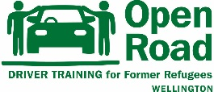
Open Road Driver Training
Expression of Interest
Wellington City
Please note this is not an application form but an Expression of Interest in the Open Road driving programme. Please complete the details below:
Name: Date:
Phone No:
Email:
Residential Address:

Please confirm the following:
- I am from a refugee background
- I have a learner or restricted licence (circle)
Licence issue date: Licence Expiry date:
- I live/ work or study in central Wellington
- If selected I am available to attend driving lessons in Wellington city twice a week for 16-20 weeks
Have you ever driven a car or had any driving lessons? Yes/No
If Yes please describe where you have driven and how much driving you have done:

Thank you for your expression of interest in our driving programme. Please return this application to kate.twyford@crf.org.nz or hand in at our office Level 4, 39 Webb St, Mount Cook. We will note your details. If you are eligible for our programme we contact you in 2021 when applications open again.
Feb 2021

